VIRTUAL EVENT HOSTING GUIDE

Zoom Meeting Quick-Links

Host and Co-Host Roles, Responsibilities and Settings

Getting Started: Navigating the Basics

Technical Roles within the Event
Understanding the roles of the host, the co-host, the alternative host and the participant is paramount when planning a virtual event. The visual breakdown of the various responsibilities will aid in assigning the roles appropriately.

Host and Co-Host Controls
Details the host/co-host controls using the toolbar

Meeting Templates
Saving meeting formats to be duplicated for similar events in the future

Changing your Meeting Settings via Zoom Web Portal
How to change the participant settings for your virtual event. For example; enabling breakout rooms, participant capabilities, muting all participants upon logging-in.
- Changing Settings in the Desktop Client or Mobile App- How to change the user settings from the Desktop Client or Mobile App

Managing Participants Settings and Controls
How to use host and co-host controls to effectively manage participants

Managing Cloud Recordings
How to access and manage saved meeting recordings

Using Audio Transcription for Cloud Recordings
How to save and view audio recordings of meetings

Controlling the Production and Participant Experience
Registration Feature
How to use the Zoom Registration feature for meetings and webinars

Setup and Manage a Waiting Room
How to set up and manage the Waiting Room feature (host and co-hosts)

Recording
Directions for using the Recording feature (hosts, co-hosts, participants)

Sharing Your Screen
Directions and tools for screen sharing on all software options

How to Spotlight Presenters
How to use the Spotlight feature (host and co-hosts)

Managing Breakout Rooms
Directions for creating and managing Breakout Rooms feature as the host

Polling for Meetings
Directions for creating and managing Polling feature as the host

Security and Privacy Controls
Details the security icon and usage during a meeting (privacy and participant controls)

Keyboard Shortcuts for Easy-Zoom'ing
Lists the keyboard functions available with the Desktop Client

Participant Controls and Settings
Attendee Controls in a Meeting
Details the personal controls available to participants while in a virtual event

How Do I Change the Video Layout?
Details the Active Speaker, Gallery, and Mini layout options, as well as viewing while screen sharing

Nonverbal Feedback During Meetings
Instructions on how to enable and manage feedback (host) and how to utilize the Nonverbal Feedback feature (participants)

Accessibility
Keyboard Shortcuts for Zoom
Lists the keyboard functions available with the Desktop Client

Language Interpretation in Meetings and Webinars
Utilizing the Language Interpretation feature provided by Zoom (host and interpreters)

Closed Captioning
Utilizing the Closed Captioning feature provided by Zoom (host and interpreters)

Integrating a Third-Party Closed Captioning Service
How to apply Closed Captioning from an outside source

Key Components to Hosting a Virtual Event

Sending a Comprehensive Meeting Invitation
The event or meeting invitation must include clear details and instructions on the ways guests can join the event. The event lead who creates the Zoom meeting or event can edit the details that are generated when an event is created in Zoom.

  - Example: Email Generated Meeting Details
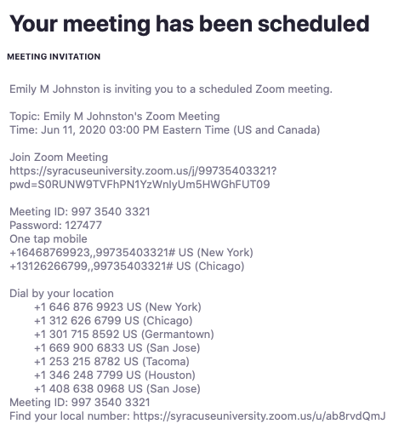

Steps to Editing the Zoom Invitation for your Event
- Include the meeting ID and password information in the meeting or event invitation.
      - *The meeting ID can be set as a default in the users Zoom Web Portal settings.

      - 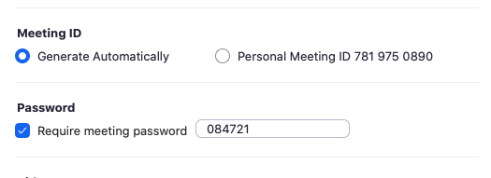
- Remove unnecessary additional or all dial-in numbers so guests can only attend virtually. See email generated image above for example.
- Identify additional digital viewing platforms for the event (optional), such as Facebook Live, Instagram Live.


Enhance the Participant Experience
The tips below will boost the viewing experience of each participant. Additional team members may be required to create key event flow documents or operate and monitor the Zoom meeting features below.

Waiting Room
Hosts and Co-hosts can utilize a virtual holding space to screen guests as they arrive, as well as ensure all technical setup for the event is complete before “letting guests in” to the event.

Start your event off with all the “need-to-know” information
Secure a speaker to deliver a robust introduction that communicates the order of the program at the top of the event. This includes:
    - Upcoming speakers or presenters
    - Alternate social media viewing locations
    - Overall event purpose
    - Preferred screen set up for best viewing experience
    - How to access the event recording (if applicable)
- Enable Q&A feature, if applicable.
- Remind your emcee to identify a clear call to action, promote upcoming events, and contact information.

Zoom Host Viewing Options
In the Zoom Meeting platform, the host cannot control the way the participant views the content, unless the host shares their screen. However, the speaker or emcee can suggest the screen set up for the best viewing experience. The host can apply the default Active Speaker layout to Zoom Meetings that feature a solo presenter, or that involve the interaction between multiple presenters.

  - Speaker View
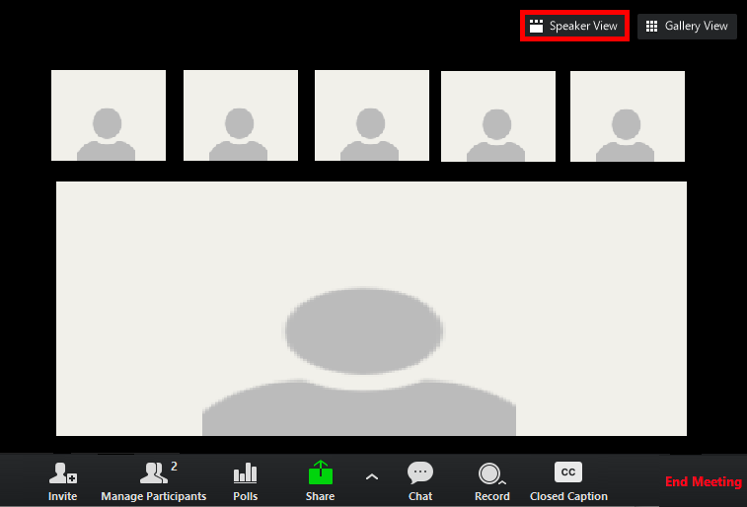

  - Gallery View
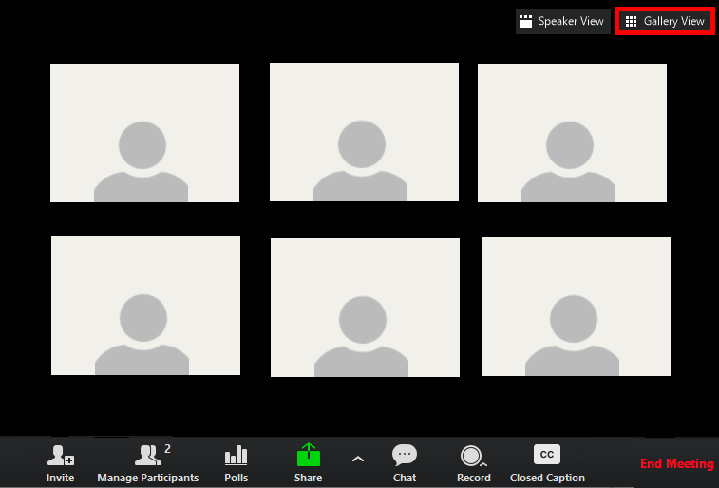

Panel Discussion Helpful Hints
The Zoom Meetings platform doesn’t allow the host to disable audio and visual features of participants or prevent other attendees from viewing each other in gallery or speaker view.

The tips below will help keep the focus on the panelists and speakers – instead of the attendees
- Always “spotlight” the primary speaker(s) to ensure their videos are locked on the participants main screen
- Set the Zoom default to “mute attendees upon entry” and remind guests to keep their microphone muted during the event
- Delegate support staff as co-hosts and monitor attendee’s video and sound settings.

Managing Keynote Speakers & Demonstrations

PREPARE, TEST AND REHEARSE! Preparation and practice lead to successful virtual events.
- The Zoom host should schedule a rehearsal with all presenters/speakers. It should be a comprehensive rehearsal; including a full run-through of remarks, lighting, computer views, sound, backgrounds and other key elements.
- Use this time to test all digital assets or visual aids while going through each segment within the run of show and/or script.

The host and co-hosts should test the following:
- Spotlighting speakers on and off
  - The Spotlight control holds a speaker’s video in focus and prevents other users’ videos from being featured in the window.
- Monitoring the program flow and manage participants
- Running reports
- Managing the waiting room
- Muting and Unmuting participants

Muting Control
It is important to always “Mute Participants Upon Entry”. Dependent on your meeting or event type, it is your discretion if you would like the individuals to be able to unmute themselves.
- As a host or co-host, Click “Manage Participants”.
- Select the individual you would like to mute or unmute, or if you would like to mute all participants.
- These settings can be changed at any time throughout the virtual meeting. 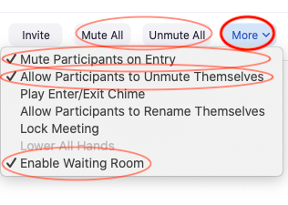

Spotlight Control
In order to make the active speaker the “focus” on all participants screen, regardless of their layout. ONLY hosts or co-hosts have the ability to spotlight individuals.
- As a host or co-host, Click “Manage Participants”.
- Select the individual you would like to spotlight, and select the option “Spotlight Video”.
- If you have multiple screens in your Zoom room, you can select which screen you would like the participant to appear on.

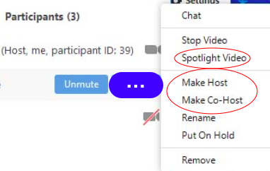

Screen Sharing Tidbits

Side-By-Side Layout
When screen sharing, all guests will notice a green toolbar that contains the View Options dropdown menu. Participants should select Side-By-Side in the menu. This option will split the layout and simultaneously show the presenter next to the shared content. Once they have stopped sharing, the screen will return to the original format.

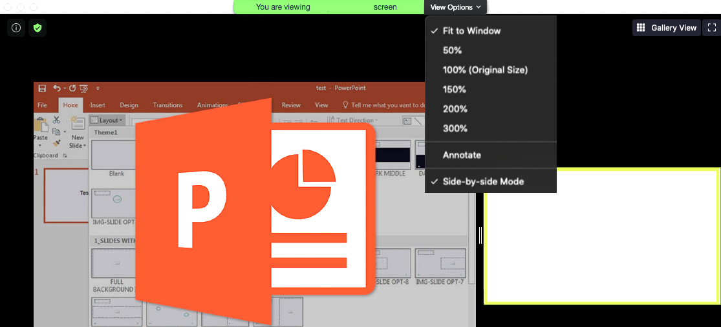

Sharing a PowerPoint or Video
The Zoom Meeting Desktop App is required for the Host to seamlessly share PowerPoint content or video. Practice sharing the presentation prior to the event with a team member for smooth transitions from presentation to speakers. The following are specific steps for sharing a PowerPoint during a Zoom Meeting.

How To Share a PowerPoint or Presentation
- Enter the Zoom Meeting and open the PowerPoint window.
- Minimize the Zoom Meeting (enter Mini Window mode).
- Begin the PowerPoint presentation or video (present Full Screen).
- Expand the Zoom Meeting Mini Window (view Full Window).
- Use the meeting controls toolbar to Share Screen and present.

Live Streaming on Social Media Platforms
Connect event content or programming to constituents on social media sites like Facebook and Instagram during your live Zoom Meetings presentation.

Tips:
- Only the Host can begin a Live Stream – check that access is enabled on the connected platforms prior to the event beginning.
- The video will transfer in the same viewing mode that is selected in the Zoom Meeting (Active Speaker, Gallery, Side-By-Side).
- Announce the streaming options to presenters and guests prior to the event – all should be aware of the sources where they may be displayed.
- For ease and security, consider a closed Zoom Meeting that is only viewable via Live Stream , so the viewers cannot “participate”.

  - Host View of Live Stream Options
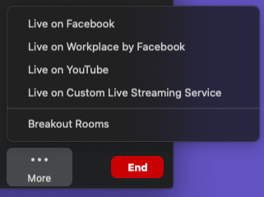

Example:
“Matters that Matter”- The Hendricks Chapel Virtual Event Series

Zoom Q&A Tips:
If applicable, invite attendees to participate in the program by asking questions to engage with the speakers
- Enable the chat or Q&A feature so attendees can post questions
- The host should avoid changing cameras/microphones or giving up any control during the Q&A
- If guests are permitted to ask questions on video, provide etiquette guidelines and implement the Raise Hand feature.
- Secure a moderator to conduct the session.
  - The moderator must prepare questions and/or take from the chat.
  - The moderator must also manage the session by monitoring the Raise Hand feature that guests should be instructed to utilize during this segment.
- Reiterate the questions that are being asked and answered in the chat
  - Reminder: Attendees on the Live Stream platforms cannot read the questions in the Zoom meeting chat.

Non-Verbal Feedback and Polling
It is recommended to use these features to respond and engage with the participants. Zoom has provided detailed instructions on incorporating polling into your virtual event .

  - Attendee Non-Verbal Feedback Options
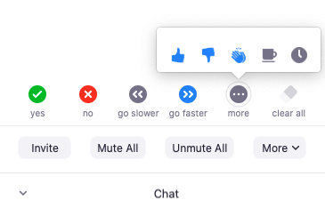

How to Create a Poll
- View “My Meetings” in the Web Portal
- Find “Polls” and select “Edit”
- Add the poll(s) to the scheduled meeting
    - 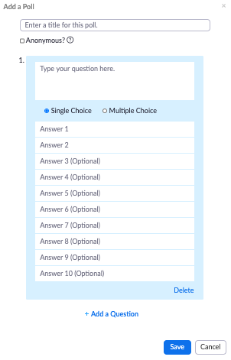
- Begin the meeting and select “Polling” from the Host Toolbar
- Select and “Launch” the poll
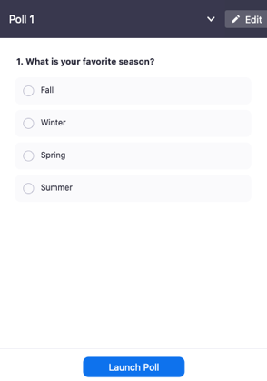

6. Select “End Poll” and share the results (optional)

